Пензенский государственный университет
Многопрофильный колледж
Кафедра "Информационно-вычислительные системы"

Лабораторная 12
по дисциплине «Основы алгоритмизации и программирования»

Выполнил: студент группы 24КИП1
Денисов Е.А Лисин И.Д.
Проверил: преподаватель СПО
Борискин Д.А.

2026
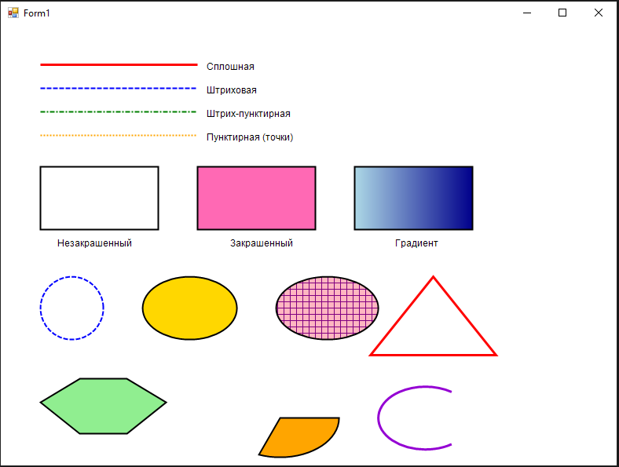

using System;
using System.Drawing;
using System.Drawing.Drawing2D;
using System.Windows.Forms;

namespace WindowsFormsApp1
{
public partial class Form1 : Form
{
public Form1()
{
InitializeComponent();
this.Paint += new PaintEventHandler(Form1_Paint);
}

private void Form1_Paint(object sender, PaintEventArgs e)
{
Graphics g = e.Graphics;

g.SmoothingMode = SmoothingMode.AntiAlias;

g.Clear(Color.White);

Pen redPen = new Pen(Color.Red, 3);
g.DrawLine(redPen, 50, 50, 250, 50);

Pen blueDashPen = new Pen(Color.Blue, 2);
blueDashPen.DashStyle = DashStyle.Dash;
g.DrawLine(blueDashPen, 50, 80, 250, 80);

Pen greenDashDotPen = new Pen(Color.Green, 2);
greenDashDotPen.DashStyle = DashStyle.DashDot;
g.DrawLine(greenDashDotPen, 50, 110, 250, 110);

Pen orangeDotPen = new Pen(Color.Orange, 2);
orangeDotPen.DashStyle = DashStyle.Dot;
g.DrawLine(orangeDotPen, 50, 140, 250, 140);

Font labelFont = new Font("Arial", 9);
SolidBrush textBrush = new SolidBrush(Color.Black);
g.DrawString("Сплошная", labelFont, textBrush, 260, 45);
g.DrawString("Штриховая", labelFont, textBrush, 260, 75);
g.DrawString("Штрих-пунктирная", labelFont, textBrush, 260, 105);
g.DrawString("Пунктирная (точки)", labelFont, textBrush, 260, 135);

Pen blackPen = new Pen(Color.Black, 2);
g.DrawRectangle(blackPen, 50, 180, 150, 80);

SolidBrush pinkBrush = new SolidBrush(Color.HotPink);
g.FillRectangle(pinkBrush, 250, 180, 150, 80);
g.DrawRectangle(blackPen, 250, 180, 150, 80);

LinearGradientBrush gradientBrush = new LinearGradientBrush(
new Rectangle(450, 180, 150, 80),
Color.LightBlue,
Color.DarkBlue,
LinearGradientMode.Horizontal);
g.FillRectangle(gradientBrush, 450, 180, 150, 80);
g.DrawRectangle(blackPen, 450, 180, 150, 80);

g.DrawString("Незакрашенный", labelFont, textBrush, 70, 270);
g.DrawString("Закрашенный", labelFont, textBrush, 290, 270);
g.DrawString("Градиент", labelFont, textBrush, 500, 270);

g.DrawEllipse(blueDashPen, 50, 320, 80, 80);

SolidBrush yellowBrush = new SolidBrush(Color.Gold);
g.FillEllipse(yellowBrush, 180, 320, 120, 80);
g.DrawEllipse(blackPen, 180, 320, 120, 80);

HatchBrush hatchBrush = new HatchBrush(
HatchStyle.Cross,
Color.Purple,
Color.LightPink);
g.FillEllipse(hatchBrush, 350, 320, 130, 80);
g.DrawEllipse(blackPen, 350, 320, 130, 80);

Point[] triangle = {
new Point(550, 320),
new Point(630, 420),
new Point(470, 420)
};
g.DrawPolygon(redPen, triangle);

Point[] hexagon = {
new Point(50, 480),
new Point(100, 450),
new Point(160, 450),
new Point(210, 480),
new Point(160, 520),
new Point(100, 520)
};
SolidBrush lightGreenBrush = new SolidBrush(Color.LightGreen);
g.FillPolygon(lightGreenBrush, hexagon);
g.DrawPolygon(blackPen, hexagon);

SolidBrush orangeBrush = new SolidBrush(Color.Orange);
g.FillPie(orangeBrush, 280, 450, 150, 100, 0, 120);
g.DrawPie(blackPen, 280, 450, 150, 100, 0, 120);

Pen thickPen = new Pen(Color.DarkViolet, 3);
g.DrawArc(thickPen, 480, 460, 120, 80, 45, 270);

redPen.Dispose();
blueDashPen.Dispose();
greenDashDotPen.Dispose();
orangeDotPen.Dispose();
blackPen.Dispose();
thickPen.Dispose();
pinkBrush.Dispose();
yellowBrush.Dispose();
lightGreenBrush.Dispose();
orangeBrush.Dispose();
textBrush.Dispose();
gradientBrush.Dispose();
hatchBrush.Dispose();
labelFont.Dispose();
}
}
}

